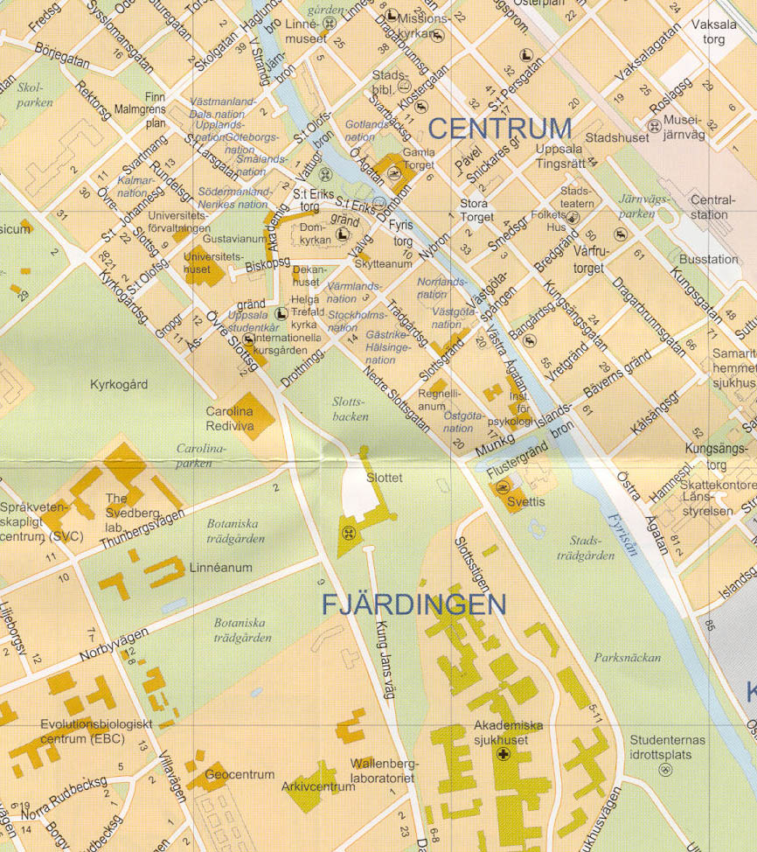
Workshop lecture hall
Basic Hotel
Reception,
Wednesday May 22
Mrs Kjällströms
Conference dinner at Restaurant Sven Dufva in this direction.
Train and bus from Arlanda Airport and Stockholm
Uppsala University
Reception May 23

Winn Hotel

